***PAAREES PERFUMES***

***CALVIN KLIEN***

***FOR WOMEN***

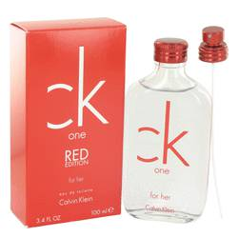

# 

***CK ONE RED***

## *Description:*

Ck One Red by Calvin Klein Perfume. Calvin Klein launched Ck One Red in 2014 as a light, delicate fragrance made for modern women. Introductory notes of powdery violet contrast with aqueous watermelon, making this a refreshing scent for spring and summer. The heart notes derive from traditional floral notes that lead into woody base notes of earthy patchouli and floral musk mineralized by white amber. Ck One Red is unassuming and light while fresh and invigorating, making it a perfect choice for daily use.